Test Case: runTestMultipleTimes
Step 1 - Enter username and password and click to button Enter : Credentials Entered
Image file-name: QC_Testing-runTestMultipleTimes-dic. 04 2025, 03 40 17 p. m.

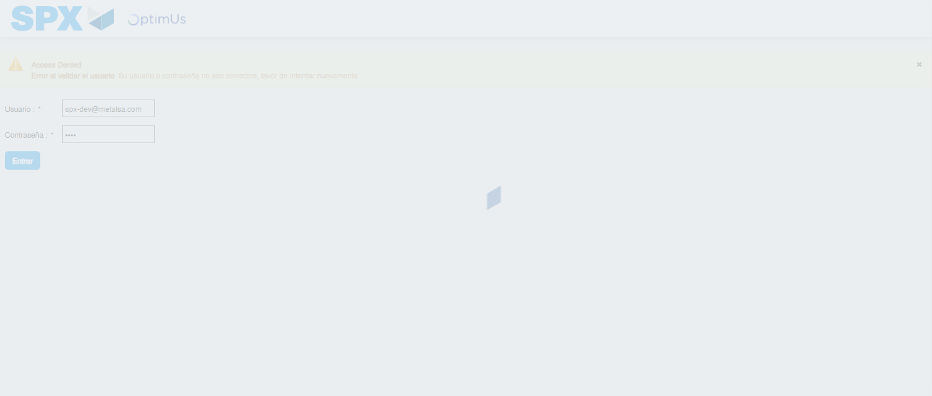Image file-name: QC_Testing-runTestMultipleTimes-dic. 04 2025, 03 40 18 p. m.

Step 2 - Select to UEN and Access to Administrador Roles Menu: UEN Correctly selected and Correct access
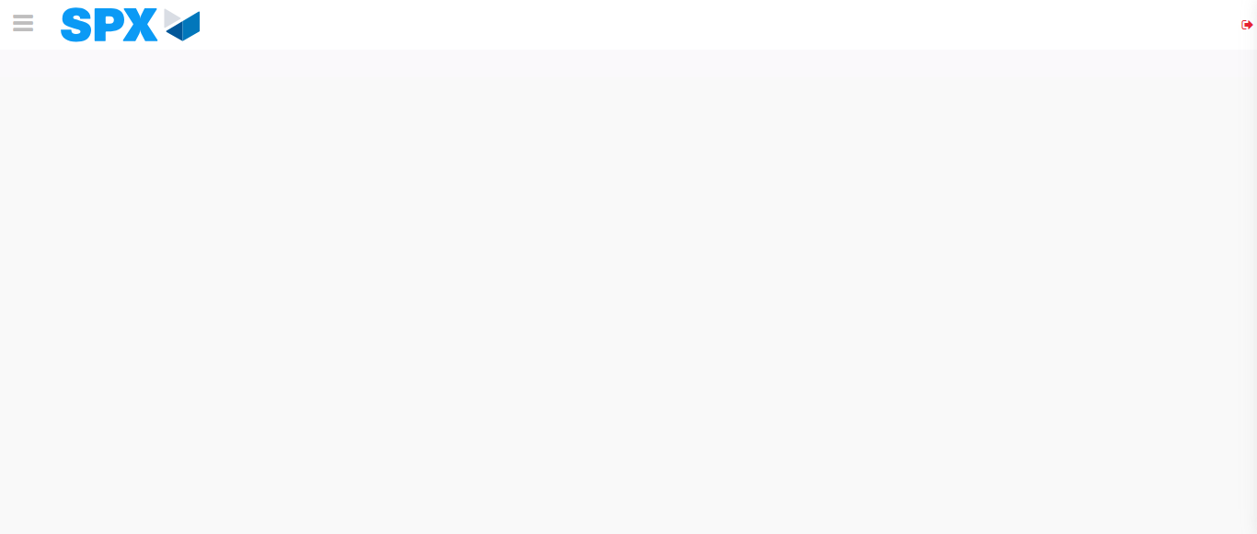Image file-name: QC_Testing-runTestMultipleTimes-dic. 04 2025, 03 40 21 p. m.

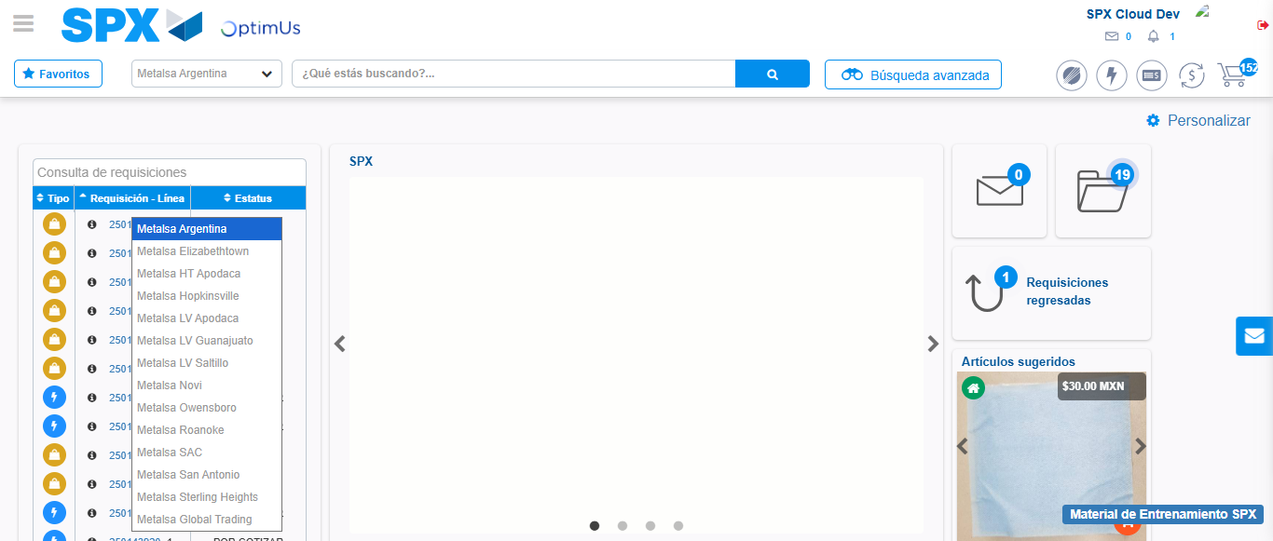Image file-name: QC_Testing-runTestMultipleTimes-dic. 04 2025, 03 40 22 p. m.

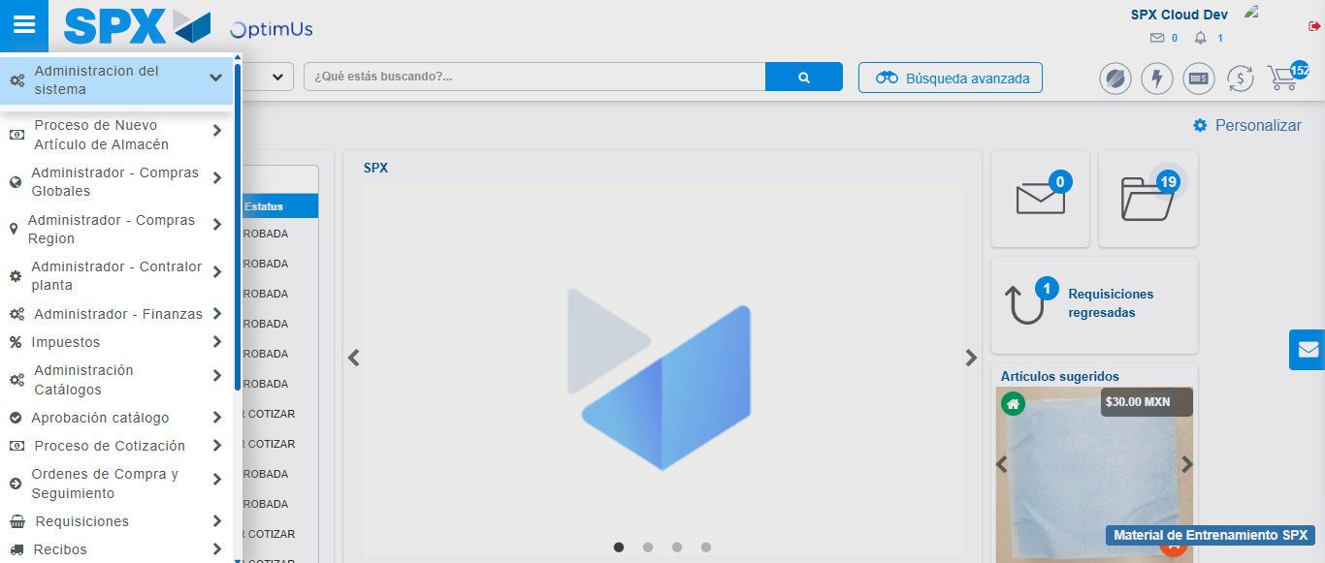Image file-name: QC_Testing-runTestMultipleTimes-dic. 04 2025, 03 40 23 p. m.

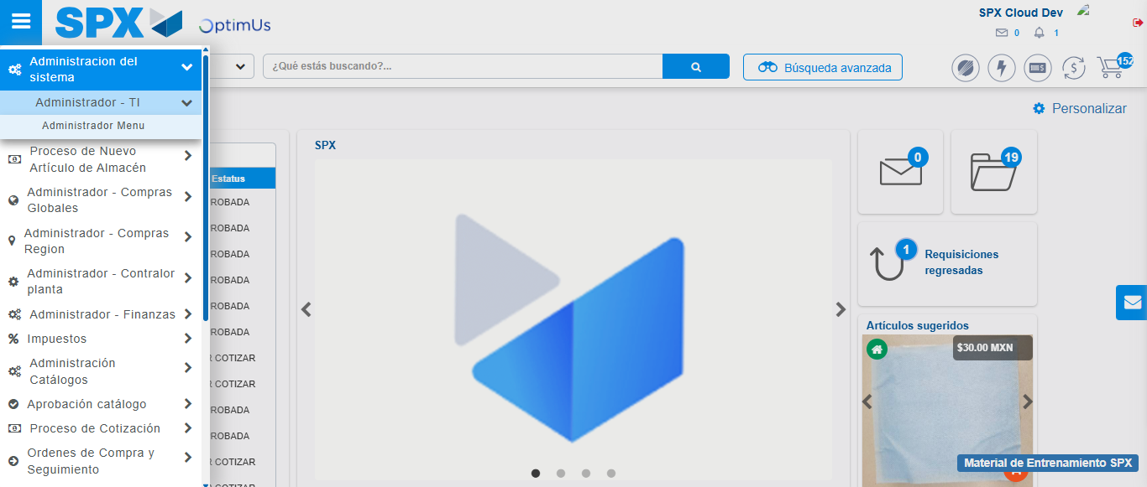Image file-name: QC_Testing-runTestMultipleTimes-dic. 04 2025, 03 40 24 p. m.

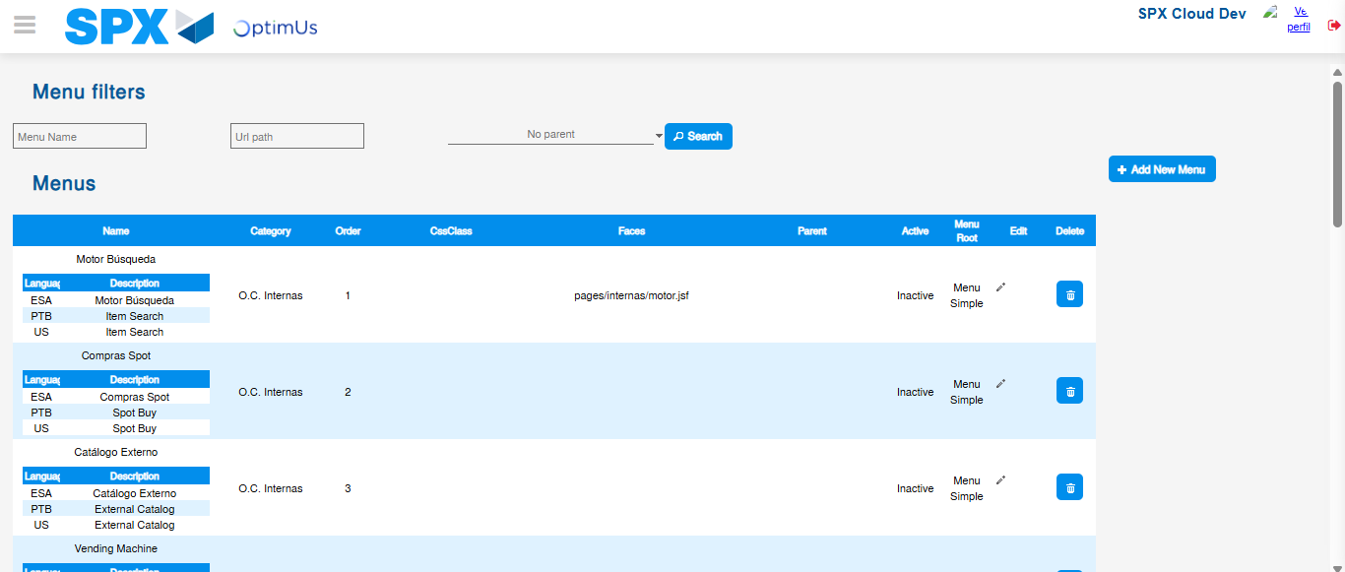Image file-name: QC_Testing-runTestMultipleTimes-dic. 04 2025, 03 40 27 p. m.

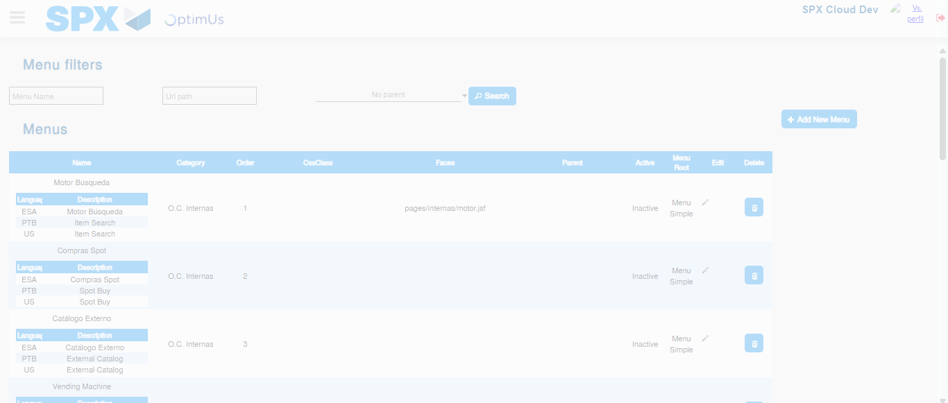Image file-name: QC_Testing-runTestMultipleTimes-dic. 04 2025, 03 40 28 p. m.

Step 3 - Add new menu and edit fields: New menu successfully registered
Image file-name: QC_Testing-runTestMultipleTimes-dic. 04 2025, 03 40 28 p. m.

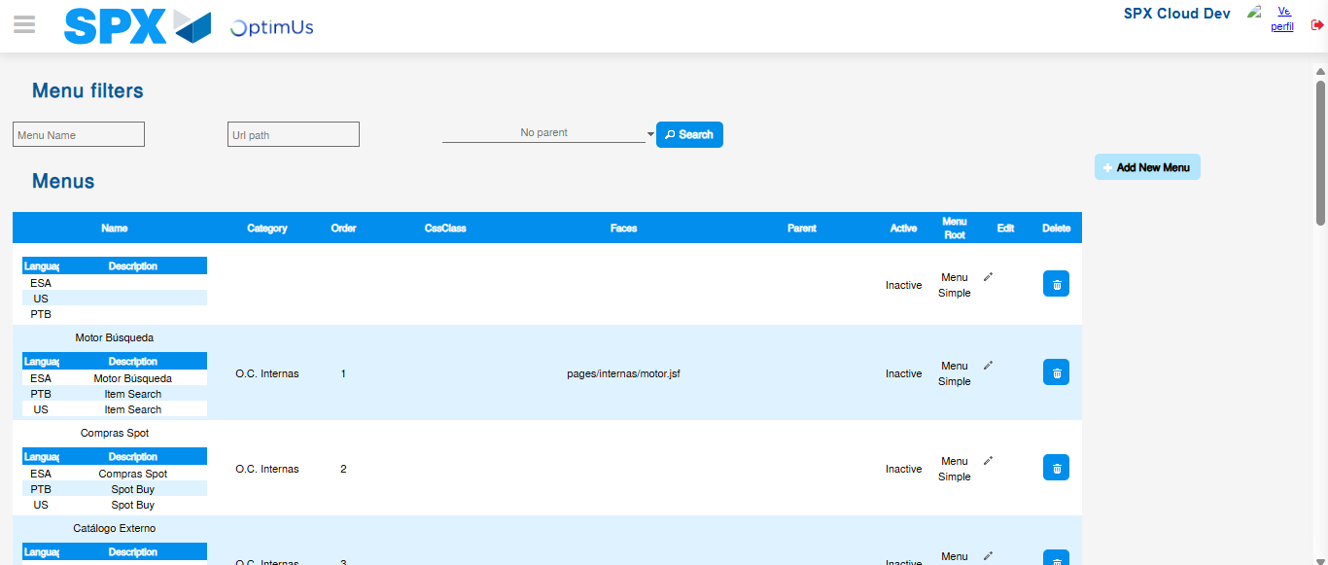Image file-name: QC_Testing-runTestMultipleTimes-dic. 04 2025, 03 40 31 p. m.

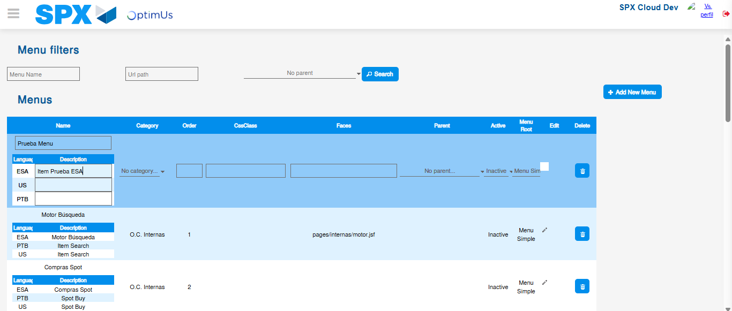Image file-name: QC_Testing-runTestMultipleTimes-dic. 04 2025, 03 40 32 p. m.

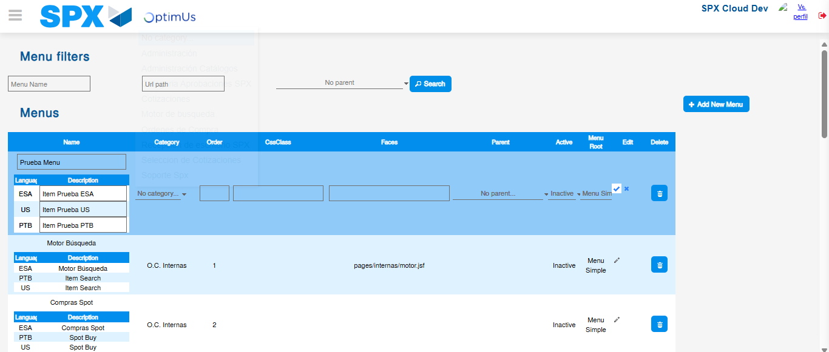Image file-name: QC_Testing-runTestMultipleTimes-dic. 04 2025, 03 40 33 p. m.

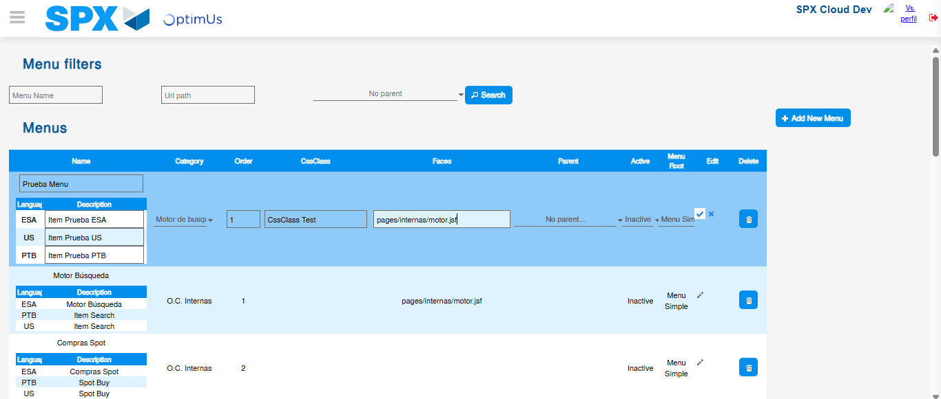Image file-name: QC_Testing-runTestMultipleTimes-dic. 04 2025, 03 40 34 p. m.

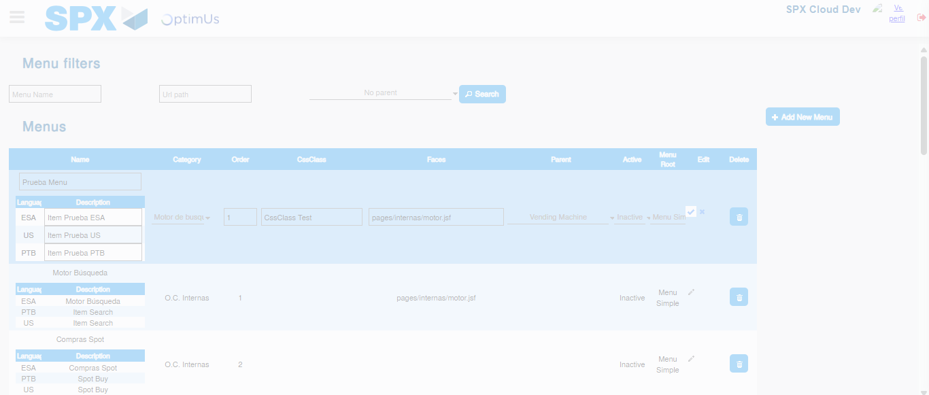Image file-name: QC_Testing-runTestMultipleTimes-dic. 04 2025, 03 40 35 p. m.

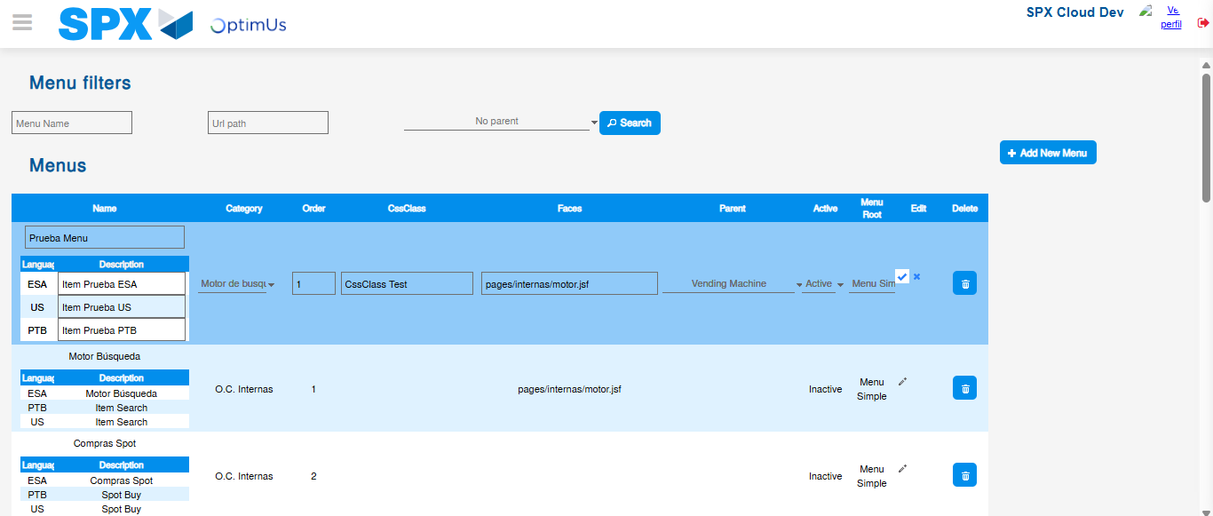Image file-name: QC_Testing-runTestMultipleTimes-dic. 04 2025, 03 40 36 p. m.

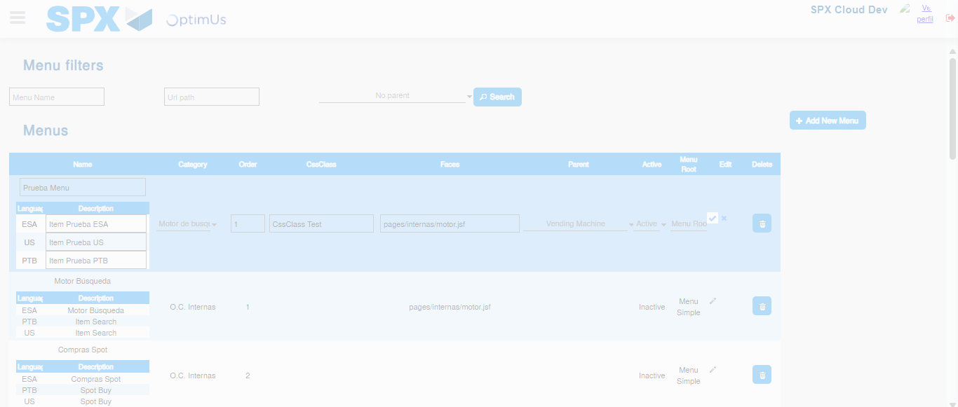Image file-name: QC_Testing-runTestMultipleTimes-dic. 04 2025, 03 40 37 p. m.

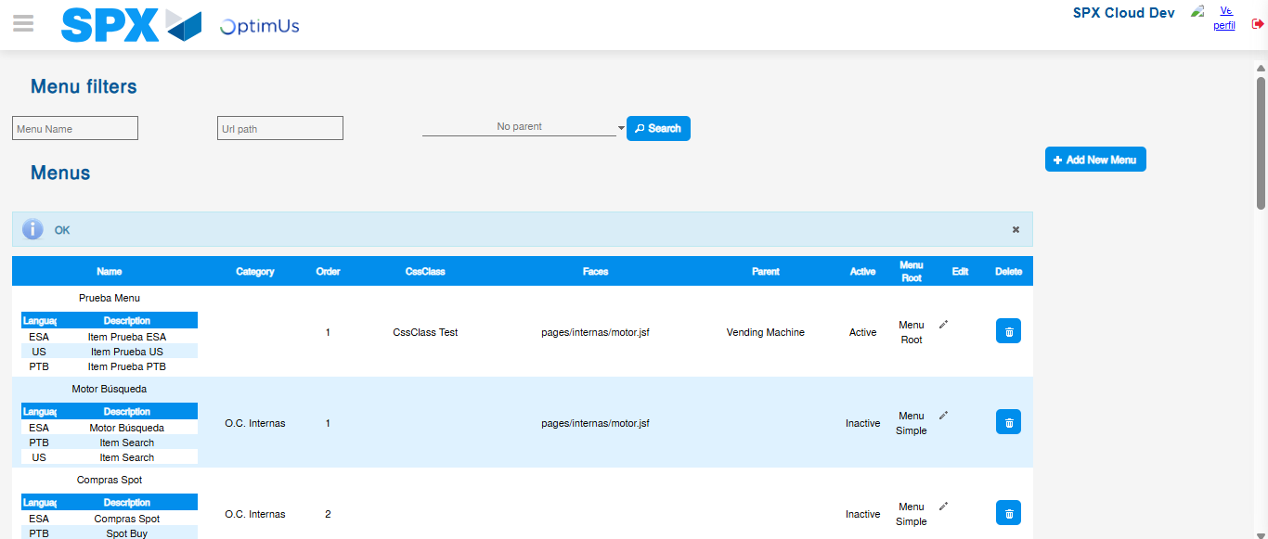Image file-name: QC_Testing-runTestMultipleTimes-dic. 04 2025, 03 40 41 p. m.

